**A PROJECT REPORT ON**

**QR BASED ATTENDANCE**

**SYSTEM**

**SUBMITTED TO THE SAVATRIBAI PHULE PUNE,**

**UNIVERSITY**

**IN PARTIAL FULFILLMENT FOR THE AWARD OF THE**

**DEGREE OF**

**BACHLOR OF ENGINEERING**

**IN**

**INFORMATION TECHNOLOGY**

**SUBMITTED BY,**

**Yash Jane – 719208…**

**Amey Potnurwar - 71920825E**

**Siddhi Agarwal – 719208…**

**Sneha Dixon – 719208…**

**UNDER THE GUIDANCE OF**

**Prof Manjusha Amritkar**

**INTERNATIONAL INSTITUTE OF INFORMATION**

**TECHNOLOGY PUNE – 411057**



**RAJIV GANDHI INFOTECH PARK PHASE I,**

**HINJAWADI, PUNE – 411057**

**411057 ACADEMIC YEAR 2021-2022**

**DEPARTMENT OF INFORMATION TECHNOLOGY**

**INTERNATIONAL INSTITUTE OF INFORMATION**

**TECHNOLOGY PUNE – 411057**

**ACADEMIC YEAR 2021-2022**

**CERTIFICATE**

This is to certify that the project report entitled

**QR BASED ATTENDENCE SYSTEM**

Submitted by

**Yash Jane**

**Amey Potnurwar**

**Siddhi Agarwal**

**Sneha Dixon**

Is a bonafide work carried out by them under the supervision of Prof. Manjusha Amritkar and it is approved for the partial fulfillment of the requirement of Savitribai Phule Pune University, for the award of the Degree of Bachelor of Engineering (Information Technology).

The project work has not been earlier submitted to any other institute or university for the award of degree or diploma.

### Prof. Manjusha Amritkar Prof.

### Internal Guide External Guide

### Prof. Jyoti Surve Dr. Vaishali Patil

### Head of the Department Principal

### 

**Date -**

**Place -**

**Acknowledgement**

We express our sincerely thanks to all those who have provided us the valuable guidance towards the successful completion of this system as a part of syllabus for the bachelor's course. We express gratitude towards our co-operative department for providing us with all the valuable assistance. We hereby take this opportunity to sincerely thank **Prof.** **Manjusha Amritkar** for her valuable guidance, inspiration, whole hearted involvement during every stage of this project and his experience, perception through professional and constant supervision as well as for providing necessary information regarding the project. We are also thankful to **Prof. Jyoti Surve -** Head of Department for his constant enlightenment, support and motivation which has been highly instrumental in successful completion of our project. We are extremely thankful to **Dr. V. N. Patil,** Principal for his encouragement.

Finally, we like to express our deep sense of gratitude towards our parents, friends and well-wishers who were always there for suggestions and help.

Amey Potnurwar

Siddhi Agarwal

Yash Jane

Sneha Dixon

**Abstract**

To monitor student engagement in a classroom, a student attendance system is required. Several manual presence-based attendance systems have been proposed. This is an extremely critical issue. The administration necessitates meticulous follow-up, care, and strict adherence. In terms of processing time and accuracy, the prior systems are inefficient. The learner merely had to use his or her device to scan the displayed QR code. Following that, the code was provided to the server for the attendance procedure. The flask api was used to plan and implement the suggested work. This is an intriguing approach for automating the standard attendance system through the use of authentication. The traditional technique necessitates keeping a register to manually note pupils' attendance, which is time intensive. As a result, the proposed project eliminates the need to keep track of attendance.

**Contents**

1. Introduction 9
   1. 1.1 Overview 9
      1. 1.1.1Project Overview 9
   2. 1.2 Brief Description 10
   3. 1.3 Motivation 10
   4. 1.4 Objectives……………………………………………………….11
   5. 1.5 Project Scope……………………………………………………….11
   6. 1.6 Applying Software Engineering Approach 11
2. Literature Survey 14

2.0.1 An Analysis System of Students' Attendance State in Classroom Based on Human Posture Recognition. …………………………. 14

2.0.2 Motion Based Attendance System in Real-Time Environment for Multimedia. ………………………………………………...14

2.0.3 NFC Based Attendance System with Facial Authorization on Raspberry Pi and Cloud Server. …………………………………………. 15

2.0.4 QR Code Based Smart Attendance System. ………………………… 15

2.0.5 A Students Attendance System Using QR Code. ……………………. 16

2.0.6 Multichannel Attendance Management System using QR Code and Location. ………………………………………………. 16

2.0.7 Student Attendance System using QR Codes. ………………………. 17

2.0.8 Enhancing the Transparency of Student Merit System Using QR Code Technology a Smart Campus Initiative. ……………………17

2.0.9 Online Attendance Monitoring System Using Face Detection and QR Code………………………………………… 18

3. Problem Statement

3.1 Justification of a problem…………………………………..

3.2 Need of a new system……………………………………....

3.3 Existing System……………………………………………..

4. Project Requirements Specification 19

* 1. Introduction 19
     1. Purpose 19
     2. Intended Audience and Reading Suggestion 19
     3. Project Scope 20
     4. Design and Implementation Constraints: 20
     5. Assumption and Dependencies: 20
  2. System Feature 21
     1. System Feature 1 21
     2. System Feature 2 21
     3. System Feature 3 21
  3. External Interface Requirements: 21
     1. User Interface: 21
     2. Hardware Interface: 21
     3. Software Interface: 22
     4. Communication Interface: 22
  4. Non-Functional Requirements: 22
     1. Performance Requirements: 22
     2. Safety Requirements: 22
     3. Security Requirements: 22
     4. Software Quality Attributes: 22

5. System Proposed Architecture 31

* 1. 5.1 System Architecture 32
     1. 5.2 Class Diagram 33
     2. 5.3 Use Case Diagram 33

5.4 Sequence Diagram………...…………………………….34

* + 1. 5.5Activity Diagram 34

**6. High level Design of Project**

6.1 Analysis Model 25

* + 1. 6.1.1 Data Flow Diagram 26
  1. 6.2 UML Diagrams 33
     1. 6.3 State Transition Diagram 27
     2. 6.4 Entity Relationship Diagram 28

6.5 System Implementation Plan 29

7. Technical Specification 35

* 1. Technology Details used in the project: 35
  2. Reference To Technology 36

7. Conclusion 37

8. References 25

**List of Figures**

|  |  |  |
| --- | --- | --- |
| Sr. No. | Figure Name | Page No. |
| 1 | DFD Level 0 Diagram | 25 |
| 2 | DFD Level 1 Diagram | 26 |
| 3 | Class Diagram | 34 |
| 4 | Use Case Diagram | 32 |
| 5 | Activity Diagram | 33 |
| 6 | System Architecture Diagram | 31 |
| 7 | Waterfall Model | 24 |
| 8 | State Transition Diagram | 27 |
| 9 | entity relationship diagram | 28 |

**List of tables**

|  |  |  |
| --- | --- | --- |
| Sr. No. | Table Name | Page No. |
| 1 | System Implementation Plan | 29 |

**Ch1 Introduction**

**1.1 Overview:**

It is common knowledge that practically all organizations, whether educational or commercial, must keep accurate records on their students' attendance in order to plan, manage, and operate effectively. In most underdeveloped countries' institutions, students' attendance is frequently taken using an ancient file system approach that involves calling students' names and using paper sheets; this method has been in use for a long time. According to them, It becomes difficult for university administrators to keep track of attendance and manually calculate the percentage of classes missed and attended for the sake of calculating subsequent results. examinations and processing With these concerns in mind, this project built and deployed a solution to address the issues with attendance recording.

**1.1.1 Project Overview:**

The suggested system uses a barcode approach to authenticate students by assigning them a unique barcode that corresponds to their unique identifier. The barcode is printed on a card that is given to each pupil. Students just scan their cards with a barcode reader, and the system records their attendance according to the dates. After then, the system saves all of the students' attendance records and provides a defaulter list and reports for the administrators. This type of application is highly handy for taking daily attendance in both school and college. Furthermore, some professors at the University of Sulaymaniyah make attendance a portion of a student's grade; as a result, students must attend classes in order to receive the greatest scores possible. However, because this information is difficult to access, several students are unaware of how many lessons they have missed. As a result, students with a high absenteeism rate may obtain poor grades or even fail a class.

# 1.2 Brief Description

**Q-R Code:**

A quick response (QR) code is a sort of barcode that encodes information as a series of pixels in a square-shaped grid and can be read simply by a digital device. QR codes are often used in marketing and advertising efforts to monitor information about products in a supply chain. QR codes are a step up from previous, one-dimensional barcodes, and the International Organization for Standardization certified them as an international standard in 2000. (ISO). QR codes are made up of black squares in a grid (matrix) on a white backdrop that are scanned by specialist software that can extract data from the patterns in the matrix. These codes can hold more data than standard barcodes and can accommodate four different types of data: alphabetic, numeric, binary, and Kanji.

To generate an encrypted QR code with specified information, the system requires a simple login process by the class instructor using its Server Module. This is something that can be done at any time. The lecturer displays an encrypted QR code to the pupils during or at the start of class. The pupils can then use the system Mobile to scan the displayed QR code. The information gathered by the Mobile Module will subsequently be communicated to the Server Module, which will confirm attendance.

**Register/Login:**

* Registration is done by teacher, student as well as parent
* Student can able to communicate with the teacher via the contact page.
* Parents can also ask their student progress via the contact page.
* Student can able to update his/her profile.
* Parent can able to see the student dashboard.

**1.2 Motivation:**

The motivation behind the system is to automate the attendance process and to conserve time in order to utilize it for studying and to increase reliability accuracy and productivity.

**1.3 Objectives:**

A web application for the teachers to generate the QR code and maintain the attendance record and web application for students to scan the QR code displayed on the screen and mark their attendance. A fully automated and clean system to maintain the records.

**1.4 Project Scope:**

The goal of the project is to digitize the way institutions collect attendance in order to provide a more comfortable and convenient experience. Because attendance tracking is totally web-based, data may be submitted from anywhere with an internet connection.

This concept is viable, and it is a prerequisite among college and university professors. There is a need for a more robust and time-efficient way of attendance based on the current system. All colleges and universities that are eager to embrace digitization and make the work of taking attendance more convenient and efficient.

# 

# 1.5 Applying Software Engineering Approach:

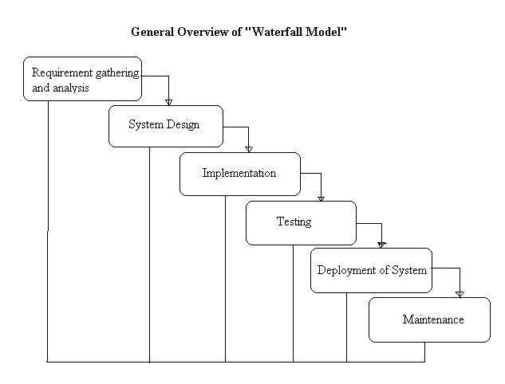

Fig. Waterfall Model

**System Implementation Plan:**

**1. Requirement gathering and analysis:**

In this step of waterfall, we identify what are various requirements are need for our project such are software and hardware required, database, and interfaces.

**2. System Design:**

In this system design phase, we design the system which is easily understood for end user i.e. user friendly.

We design some UML diagrams and data flow diagram to understand the system flow and system module and sequence of execution.

**3. Implementation:**

In implementation phase of our project we have implemented various module required of successfully getting expected outcome at the different module levels.

With inputs from system design, the system is first developed in small programs called units, which are integrated in the next phase. Each unit is developed and tested for its functionality which is referred to as Unit Testing.

**4. Testing:**

The different test cases are performed to test whether the project module are giving expected outcome in assumed time.

All the units developed in the

implementation phase are integrated into a system after testing of each unit. Post integration the entire system is tested for any faults and failures.

**5.** **Maintenance:**

There are some issues which come up in the client environment. To fix those issues patches are released, also to enhance the product some better versions are released. Maintenance is done to deliver these changes in the customer environment.

All these phases are cascaded to each other in which progress is seen as flowing steadily downwards like a waterfall through the phases. The next phase is started only after the defined set of goals are achieved for previous phase and it is signed off, so the name "Waterfall Model". In this model phases do not overlap.

**CH2 LITERATURE SURVEY**

**Paper 1:** An Analysis System of Students' Attendance State in Classroom Based on Human Posture Recognition

**Author Name:** Feng, Y., Zhang, L., Zhang, Y., Li, X., & Zhu, Q.

**Year:**2020

**Description:** The efficiency of lectures is measured by the listening state. We could use various human gesture recognition algorithms to build a system to evaluate the students' listening condition, as proposed by various human gesture recognition algorithms. The basic theories have matured to fulfil various complex assignments as a result of the spring of numerous exceptional machine vision algorithms. The solution presented here is a form of combination of different technologies, which will require additional innovation when applied. Also, in our culture, we have a lot of unused surveillance video resources that should be used, but aren't. The schools have extensive surveillance video resources, particularly in the classroom. The technology is designed to analyze the students' current state using human posture recognition. Its primary idea is the recognition of critical spots on the human body, including the body's most important points.

# Paper 2: Motion Based Attendance System in Real-Time Environment for Multimedia Application

**Author Name:** [Mayank Yadav](https://ieeexplore.ieee.org/author/37086441611); [Anmol Aggarwal](https://ieeexplore.ieee.org/author/37086437965); [Nitin Rakesh](https://ieeexplore.ieee.org/author/37394749900)

**Year:**2018

**Description:** Modern classrooms are outfitted with a variety of smart devices that work in tandem with accompanying software to improve the learning environment. However, it is frequently seen that class time is squandered taking attendance, or that the class may be disrupted by late entry of pupils, and that this attendance practice is repeated. The presence of the student in the institute has an impact on performance as well. Calling the student's name, using a sensor-based card (RFID sensor), or using a biometric fingerprint-based attendance system are all inefficient techniques for taking attendance because they cannot identify whether the student has attended the entire class.

**Paper 3:** NFC Based Mobile Attendance System with Facial Authorization on Raspberry Pi and Cloud Server

**Author Name:** Siti Ummi Masrour, Andrew Fiade, Imelda Ristanti Julia

**Year:**2018

**Description:** An attendance system is a system that is used to track a person's attendance and is used at many institutions. Many systems for taking attendance, however, have drawbacks, such as the traditional method having a drawback in the data of the attendance that the list is difficult to reuse, and a biometric attendance system having a drawback in the existence of human error, such as fingerprint scans not being acceptable due to the condition of a wet finger, dirty, too dry, or peeling fingertips. In this study, we present a mobile attendance system with NFC and face authorization to enhance security and the ability to store data in the cloud using Raspberry Pi. This study begins by summarising previous research in the fields of attendance management, NFC, face authorization, microcomputers, and cloud storage.

**Paper 4:** QR Code Based Smart Attendance System

**Author Name:** Xiong Wei , Anupam Manori , Nandgopal Devnath , Nitin Pasi , and Vivek Kumar

**Year:**2017

**Description:** Smartphones play an important role in our daily lives in this technological age. Smartphones can now handle the majority of problems fast and easily. With many social apps, business apps, problem-solving apps, educational apps, and marketing apps, it has made everyone's life simpler and easier. Following the lead of technology, the paper devised a technique to address a problem with attendance records. The suggested system consists of two applications: one for creating QR codes by entering student information, and another for taking attendance and generating attendance reports in CSV or XLS format. In order to validate a student's attendance, the teacher must scan the QR code of that student. The paper explains how the system authenticates students' identities in order to prevent fraudulent registrations. The system is in charge of managing and evaluating all students' attendance. The lecturer will be given the student QR code in order to take their attendance.

**Paper 5:** A Students Attendance System Using QR Code

**Year:**2014

**Author:** Fadi Masalha, Nael Hirzallah

**Description:** Smartphones are increasingly replacing PCs and notebooks as customers' preferred companions. Knowing that the majority of smartphone users are between the ages of 26 and 30, using smartphones to speed up the process of taking attendance by university instructors would reduce lecture time and so improve the educational process. This study suggests a QR code-based method for displaying information to students during or at the start of each lecture. To validate their attendance, the students will need to scan the code. The document explains the proposed system's high-level implementation specifics. It also explains how the system verifies student identity in order to prevent fraudulent registrations.

**Paper 6:** Multichannel Attendance Management System using QR Code and Location

**Year:** 2021

**Author:** Apurva Patil, Komal Lonkar , Veda Kowale , Archana Kotangale

**Description:** With the advancement of technology and the numerous possibilities accessible, it is critical to rethink and optimize the current manual process by combining technologies such as web and mobile. Mobile phones are becoming an integral part of our daily lives, and they have also evolved into a form of identification. We can precisely find and authenticate one's presence using the cellphone and its geo tagging capability. Mobile's inherent capabilities can be effectively used to modernize the current manual attendance system. One of the capabilities of mobile phones that allows them to swiftly capture and analyses data is QR Code scanning. Smartphones can be utilized to speed up the attendance procedure.

**Paper 7:** Student Attendance System using QR Codes

**Author:** Dewi Rahmawati , Fidi Wincoko Putro , Ardian Yusuf Wicaksono , and Arliyanti Nurdin

**Description:** To monitor student engagement in a classroom, a student attendance system is required, particularly at Institute Technology Telkom Surabaya. Several manual presence-based attendance systems have been proposed. This is an extremely critical issue. The administration necessitates meticulous follow-up, care, and strict adherence. In terms of processing time and accuracy, the prior systems are inefficient. The goal of this study is to propose a student attendance system based on a mobile application that uses QR codes. To ensure that students stay in class, a QR code with time information was created and shown throughout the lecturer's presentation. The learner merely needed to use his or her Android or iOS smartphone to scan the displayed QR code. Following that, the code was provided to the server for the attendance procedure.

**Paper 8:** Enhancing the Transparency of Student Merit System Using QR Code Technology: A Smart Campus Initiative

**Year :**2021

**Author:** Muhammad Azhad Hilmi Muhammad Aiman Hilmi , Salfarina Abdullah2 , Sazly Anuar , Masnida Hussin

**Description:** Information systems are being used in human daily activities as a result of technological advancements. Computer systems have aided in the advancement of modern human lifestyles by simplifying and facilitating tasks like as music listening, food shopping, and connecting with individuals all over the world. One of the concerns to be addressed as we prepare for smart campus projects is The issue of openness in certifying the student attendance system, which is employed on many campuses and during university activities, was addressed. The use of technologies such as QR codes and facial recognition to verify a student's attendance has undoubtedly had a positive impact. aided in the resolution of this problem

**Paper 9:** Online Attendance Monitoring System Using Face Detection and QR Code

**Year:** 2021

**Author:** Sonali Pandagre , Rupika Jadam ,Akansha Debbey , Bhagyashree Asare, Shikha Patankar , ,Kajal Arya, Deepti Dadhore, Sanjay kalamdhad

**Description:** On the basis of online classes, the online attendance monitoring system (OAMS) is primarily focused on student attendance or any organization employee attendance such as educational institutes for the public and private sectors. The manual method, which takes a lot of time and is difficult to maintain, will be replaced by an online attendance monitoring system. There are a variety of technologies available for taking attendance, but these are the most effective. The purpose of the Online Attendance Monitoring System is to record student data and keep it in a database. This app uses a QR code or face detection to take attendance online. The Online Attendance Monitoring System is a web-based application that may be used on a computer or an Android phone.

**Paper 10**: Smart Attendance System Applying QR Code

**Year:**2017

**Author:** Md Rizal Md Hendry, Mohd Noah A. Rahman and Afzaal. H. Seyal

**Description:** The primary goal of this research is to present an automated student attendance system that has been conceptualized and constructed for use in a vocational school. This study focuses on creating a QR code-based application. This technology allows us to expedite the process of collecting attendance, which saves us time in the classroom. This is being done to help students avoid the penalty of poor attendance, which could lead to them being barred from taking their final test as mandated by the authorities.

**CH 3 PROBLEM STSTEMENT**

**3.1 Justification of Problem:**

Under the era of digitalization, this project focuses on automating the tedious manual attendance process. Malpractices by students results in inaccurate attendance data, which is unacceptable, Additionally, manually recording attendance is a time-consuming and tedious process for both teachers and students. There is a lack of synchronicity and data flow because this process comprises several participants and sub-processes that function independently.

**3.2 Need of a New System:**

As we discussed the problem in the above statement so to automate and simplify this process the proposed project has a web app for student teacher and parents to operate, organize and monitor the attendance which is costless efficient and reliable.

**3.3 Existing System:**

There are many existing systems like finger print scanner, facial resignation and lot more but they have high setup and maintenance cost as well as chances to crash and chances of malpractice.

**CH 5**

**SOFTWARE REQUIREMENTS SPECIFICATION**

# Introduction:

A software requirement document expresses software needs. The software requirement specification (SRS) is the formal statement of what system developers are required to do. The requirement description and specification are both included in this requirement document. The software requirement document is not the same as the paper that was designed. It should state what the system should achieve without elaborating on how it should be accomplished. This document's requirement is complete because it meets the following criteria: It specifies the system's outward behaviors. It also specifies implementation constraints and is simple to update.

**Purpose:**

QR codes are used to store large amounts of data in a little amount of area. When students scan this QR code, their attendance is immediately recorded based on their user id. On their dashboard, it also shows the total count or percentage of a student's attendance.

**Advantages:**

1. Students will be more punctual in attending class now that no signature on the attendance sheet is necessary.

2. Teachers do not have to squander 15 minutes of an hour of their time taking student attendance.

3. There is no need to keep track of attendance because it is saved electronically in a database.

4. The approach aids professors in quickly identifying defaulters.

5. A user can quickly obtain a student's attendance history.

6. It helps the institute save time, money, effort, and resources.

**Application:**

1. The system can be used for schools, college, or universities for taking down attendance.

**USE CLASSES AND CHARACTERISTICS**

Our system is divided into two class/modules:

1. user
2. system

**ASSUMPTIONS AND DEPENDENCIES**

1. User must have the knowledge of web-based application.
2. User must have the knowledge of English.
3. User must have all required software to run the application.

**FUNCTIONAL REQUIRMENTS**

1. It should be able to predict virtual trail clothes
2. It should be able to predict presence of intruder.
3. Performance of the functions and every module must be well. The overall performance of the software will enable the users to work efficiently.
4. The application is designed in modules where errors can be detected and fixed easily. This makes it easier to install and update new functionality if required.
5. User information can only view by user himself/herself.

**EXTERNAL INTERFACE REQUIREMENTS**

1. **USER INTERFACES**

The requirements section of hardware includes minimum of 180 GB hard disk and 4 GB RAM with 2 GHz or higher speed. The primary requirements include a memory of 4GB for the Android Application development and MySQL

1. **HARDWARE INTERFACES**

As this is an online application for product management we are not enabling or installing any hardware components for user interface.

It’s not an embedded system

* Processor - Pentium IV 2.4 GHZ
* Speed - 1.5 GHz and Above
* RAM - 4 GB (min)
* Hard Disk - 220 GB
* Key Board - Standard Windows Keyboard
* Mouse - Two or Three Button Mouse

1. **SOFTWARE INTERFACES**

This is the software configuration in which the project was shaped. The programming language used, tools used, etc. are described here.

* Operating System : Windows
* Front End : HTML, CSS, Bootstrap, JavaScript
* Tool : Sublimetext3, PyCharm
* Database : MySQL

1. **COMMUNICATION INTERFACES**

* User can access the web application from remote location.
* Standard internet connection is required.
* TCP/UDP connection will be required.

**NON-FUNCTIONAL REQUIREMENTS**

**1. PERFORMANCE REQUIREMENTS**

* High Speed:

System should process requested task in parallel for various action to give quick response. Then system must wait for process completion.

* Accuracy:

System should correctly execute process, display the result accurately. System output should be in user required format.

1. **SAFETY REQUIREMENTS**

The data safety must be ensured by arranging for a secure and reliable transmission media. The source and destination information must be entered correctly to avoid any misuse or malfunctioning. Password generated by user is consisting of characters, special character & number so that password is difficult to hack. So, that user account is safe.

1. **SECURITY REQUIREMENTS**

Secure access of confidential data (user’s details).

* Information security means protecting information and information systems from unauthorized access, use, disclosure, disruption, modification or destruction.
* The terms information security, computer security and information assurance are frequently incorrectly used interchangeably. These fields are interrelated often and share the common goals of protecting the confidentiality, integrity and availability of information; however, there are some subtle differences between them.
* User password must be stored in encrypted form for the security reason
* All the user details shall be accessible to only high authority persons.
* Access will be controlled with usernames and passwords.

1. **SOFTWARE QUALITY ASSURANCE**

* Availability [related to Reliability]
* Modifiability [includes portability, reusability, scalability]
* Performance
* Security
* Testability
* Usability [includes self-adaptability and user adaptability]

1. **SYSTEM REQUIREMENTS**

* **DATABASE REQUIREMENTS**

MySQL: MySQL is an open-source relational database management system (RDBMS). Its name is a combination of "My", the name of co-founder Michael Wideness’s daughter, and "SQL", the abbreviation for Structured Query Language.

MySQL is free and open-source software under the terms of the GNU General Public License, and is also available under a variety of proprietary licenses. MySQL was owned and sponsored by the Swedish company MySQL AB, which was bought by Sun Microsystems (now Oracle Corporation). In 2010, when Oracle acquired Sun, Wideners forked the open-source MySQL project to create MariaDB.

MySQL is a component of the LAMP web application software stack (and others), which is an acronym for Linux, Apache, MySQL, Perl/PHP/Python. MySQL is used by many database-driven web applications, including Drupal, Joomla, phpBB, and WordPress. MySQL is also used by many popular websites, including Facebook, Flickr, Media Wiki, Twitter, and YouTube.

1. **SOFTWARE REQUIREMENTS**

* Operating system : Windows 7 and above.
* Coding Language : Python,
* IDE : Sublimetext3 PyCharm

1. **HARDWARE REQUIREMENTS**

* System :         Intel I3 Processor and above.
* Hard Disk           : 200 GB.
* Monitor : 15 VGA Color.
* Ram : 4 GB.

**CH 5 Proposed System Architecture:**

**5.1 System Architecture**

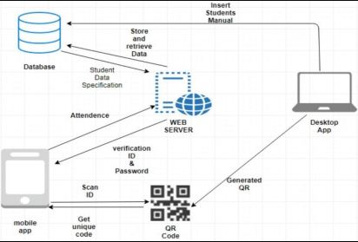

Fig.System Architecture

To achieve the above discussed objectives, a step-by-step methodology has been followed. The details of methodology are given below:

1]Generation a QR code

2]Scanning the QR code

1 Generation a QR code:

In the proposed system every QR code is embedded with a unique data for example (string). This is the specialty of the system also it generates a unique QR code every time for each and every student for every lecture in the class for a particular amount of time which is set by the server. The QR consist of a sting which has unique id and a time which will be valid for a given time these two attributes increase the authenticity of the QR and at the end the generated file will be saved as .png format for example <T18022.png>.By using smtp server we send unique QR code to student’s respective ID’s after generating in the form of png file.

QR Architecture

Formula For Generating the QR is a follow:

QR= unique_id<space>generation_time

e.g., t18063_43572886

2 Scanning the QR Code:

The very first step is to open the application in student’s side and then open a scanner. after scanning the QR the scanner will get two attributes one will be student’s IRN string and other will be the time, Now the time which will the scanner give should be in the session time otherwise it will give be invalid. Also, a specific QR will be active for limited time only; after that it will be invalid also the system has master database table in which every record will be stored. Just after generating QR’s, in database table there is a status column in which every student will be marked as absent i.e. A, and after scanning the QR status will change to Present i.e., P.

**5.2 Class Diagram:**

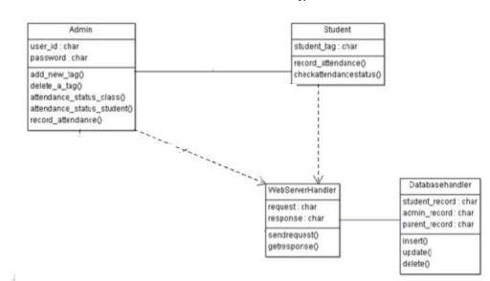

Fig. Class diagram

**5.3 Use case Diagram**

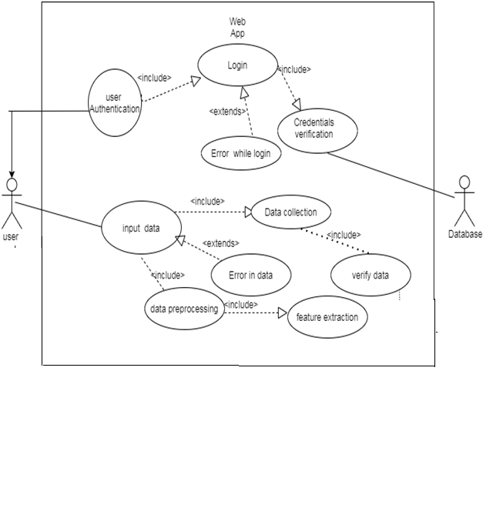

Fig. Use case diagram

**5.4 Sequence Diagram:**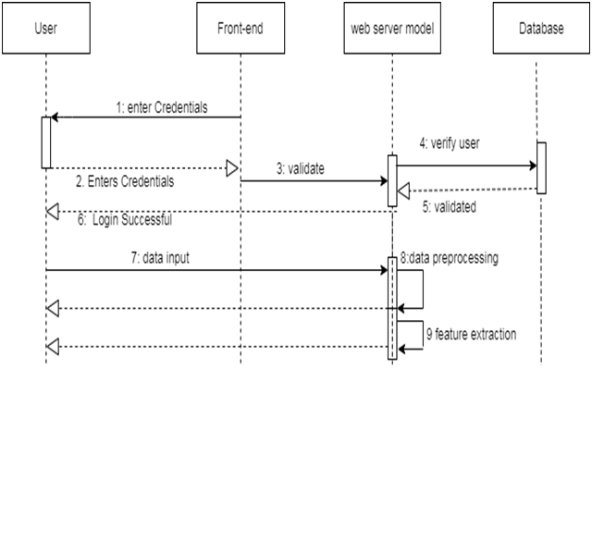

Fig. Sequence diagram

**5.5 Activity Diagram:**

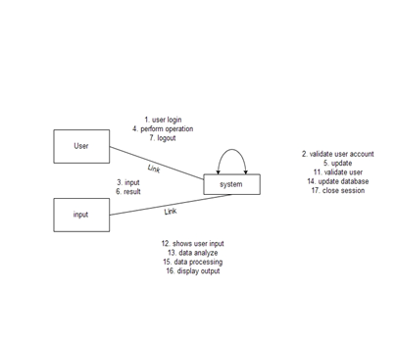

Fig. Activity diagram

**6.HIGH LEVEL DESIGN OF PROJECT**

# 6.1 Analysis Model

Dataflow Diagram:

**6.1.1 DFD**

**DFD 0**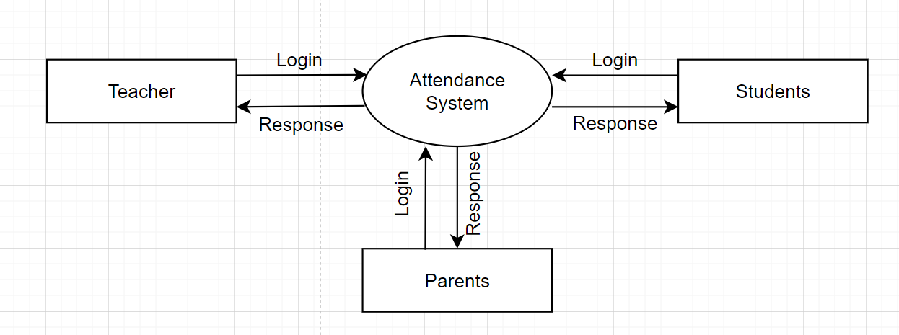

Fig. DFD 0

**DFD 1:**

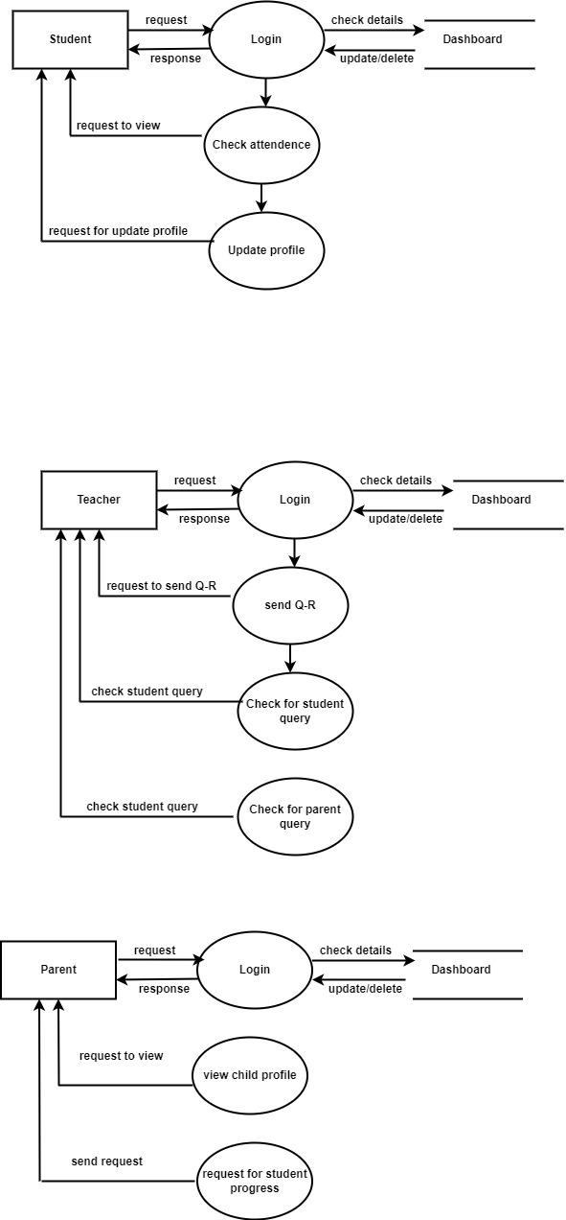

Fig DFD 1

**6.2 State Transition Diagram:**

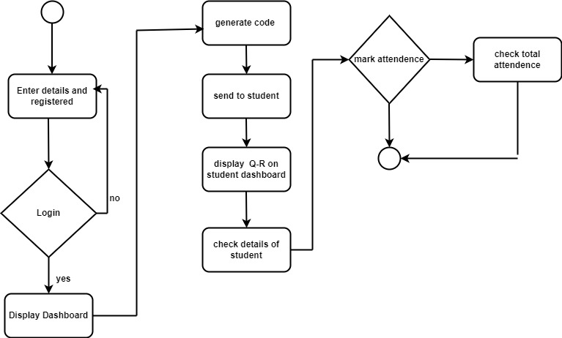

Fig. State Chart diagram

**6.3 Entity Relationship Diagram:**

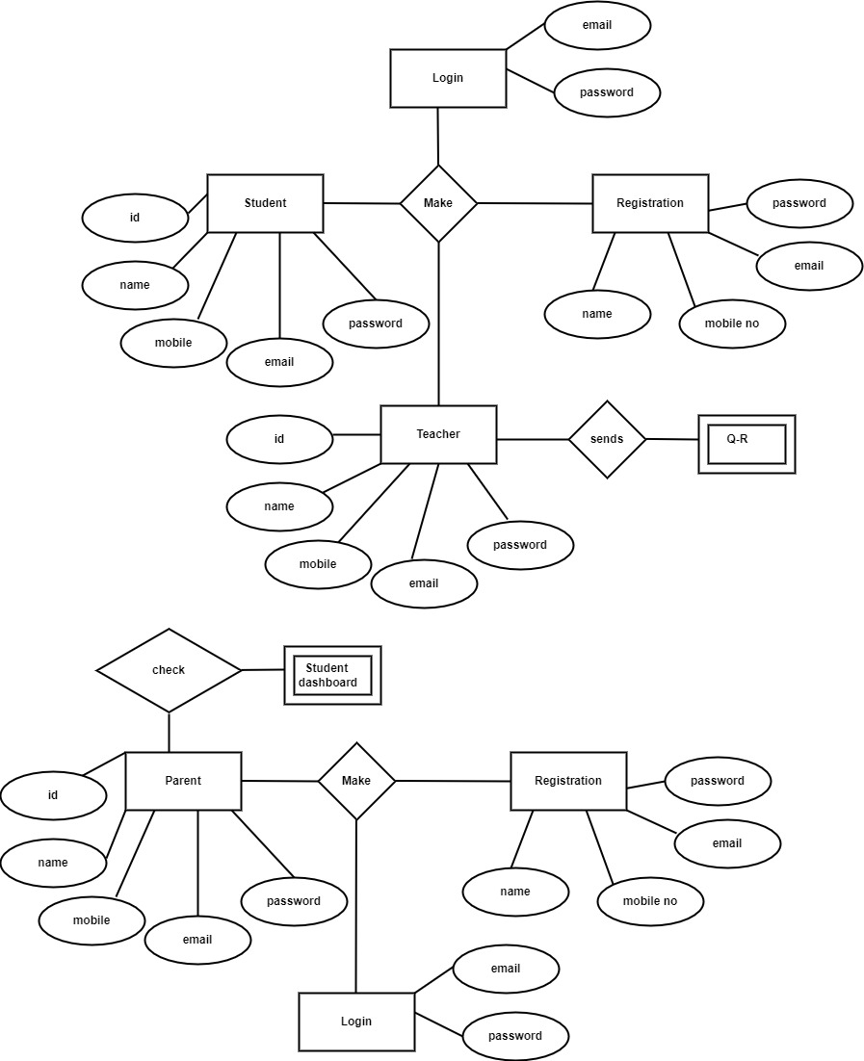

Fig. E-R Diagram

# 6.4 System Implementation Plan:

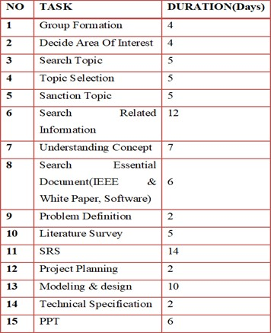

Fig. Implementation Plan

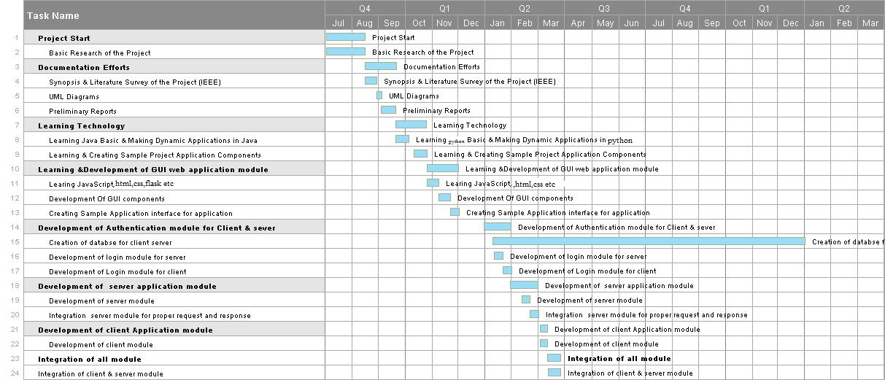

Fig. Gantt chart

**CH 7 TECHNICAL SPECIFICATION**

**Technology Details used in the project**

**Flask API**

Flask is a Python framework that allows developers to customize how users interact with data. Flask is a "micro-framework" based on the WSGI toolkit from Werkzeug and the templating engine from Jinja 2. It's intended to be used as a web framework for creating RESTful APIs.

Flask is one of the most popular Python frameworks, and several well-known websites, including as Netflix, Pinterest, and LinkedIn, use it in their development stacks. Here's an example of how Flask may allow users to use the HTTP GET method to retrieve data from a server.

**HTML**

The Hypertext Markup Language, or HTML is the standard markup language for documents designed to be displayed in a web browser. It can be assisted by technologies such as Cascading Style Sheets (CSS) and scripting languages such as JavaScript.

Web browsers receive HTML documents from a web server or from local storage and render the documents into multimedia web pages. HTML describes the structure of a web page semantically and originally included cues for the appearance of the document.

HTML elements are the building blocks of HTML pages. With HTML constructs, images and other objects such as interactive forms may be embedded into the rendered page. HTML provides a means to create structured documents by denoting structural semantics for text such as headings, paragraphs, lists, links, quotes and other items. HTML elements are delineated by *tags*, written using angle brackets. Tags such as <img /> and <input /> directly introduce content into the page. Other tags such as <p> surround and provide information about document text and may include other tags as sub-elements. Browsers do not display the HTML tags, but use them to interpret the content of the page.

**CSS**

Cascading Style Sheets (CSS) is a style sheet language used for describing the presentation of a document written in a markup language such as HTML.CSS is a cornerstone technology of the World Wide Web, alongside HTML and JavaScript.

CSS is designed to enable the separation of presentation and content, including layout, colors, and fontsThis separation can improve content accessibility; provide more flexibility and control in the specification of presentation characteristics; enable multiple web pages to share formatting by specifying the relevant CSS in a separate .css file, which reduces complexity and repetition in the structural content; and enable the .css file to be cached to improve the page load speed between the pages that share the file and its formatting.

Separation of formatting and content also makes it feasible to present the same markup page in different styles for different rendering methods, such as on-screen, in print, by voice (via speech-based browser or screen reader), and on Braille-based tactile devices. CSS also has rules for alternate formatting if the content is accessed on a mobile device.

**ORM Technique**

An object-relational mapper (ORM) is a code library that automates the transfer of data stored in relational database tables into objects that are more commonly used in application code. ORMs provide a high-level abstraction upon a relational database that allows a developer to write Python code instead of SQL to create, read, update and delete data and schemas in their database. Developers can use the programming language they are comfortable with to work with a database instead of writing SQL statements or stored procedures.

**Python Language**

Python is an interpreted high-level general-purpose programming language. Its design philosophy emphasizes code readability with its use of significant indentation. Its language constructs as well as its object-oriented approach aim to help programmers write clear, logical code for small and large-scale projects. Python is dynamically-typed and garbage-collected. It supports multiple programming paradigms, including structured (particularly, procedural), object-oriented and functional programming. It is often described as a "batteries included" language due to its comprehensive standard library.

**Ch6 CONCLUSION**

The potential application to eliminate the need for manual attendance taking at institutions across the country. This gives a low-cost automated alternative to the institution's current high-cost attendance management software. Scanning and taking attendance are considerably more enjoyable and user-friendly experiences for students and professors, enabling users save maximum effort and time while improving their experience. The overall structure of time value to the regular running of lectures will benefit users who scan and take attendance, as well as being identified as digital technology users. The project's future goals to incorporate it into a classroom platform and provide a full experience for the institution.

**CH7 REFERENCES**

[1] He k, Gkioxari G ,Dollár P, et al. Mask r-cnn[C]//Proceeding of the IEEE international conference on computer vision. 2017: 2961-2969.

[2] Reddi S J, Hefny A, Sra, et al. On variance reduction in stochastic gradient descent and its asynchronous variants[C]//Advances in neural information processing systems. 2015: 2647-2655.

[3] Liao R, Yu S, An W, et al. A model-based gait recognition method with body pose and human prior knowledge[J]. Pattern Recognition , 2020, 98: 107069. ‘

[4] Yan S, Xiong Y, Lin D. Spatial temporal graph convolutional networks for skeleton-based action recognition[C]//Thirty-second AAAI conference on artificial intelligence. 2018.

[5] Yi Y, Li A, Zhou X. Human action recognition based on action relevance weighted encoding[J]. Signal Processing: Image Communication, 2020, 80: 115640.

[6] Xu S, Liang L, Ji C. Gesture recognition for human–machine interaction in table tennis video based on deep semantic understanding[J] .Signal Processing: Image Communication, 2020, 81: 115688

[7] Jiang D, Wu K, Chen D, et al. A probability and integrated learning based classification algorithm for high-level human emotion recognition problems[J]. Measurement, 2020, 150: 107049.

[8] Shen M, Yu P, Wang R, Yuan J, Xue L. Image super-resolution reconstruction via deep network based on multi-staged fusion [J]. Journal of Image and Graphics, 2019,24(08):1258-1269.

[9] Li Y, Deng H, Xiang S, Wu J, Zhu L. Depth map super-resolution reconstruction based on the texture edge-guided approach[J]. Journal of Image and Graphics ,2018,23(10):1508-1517